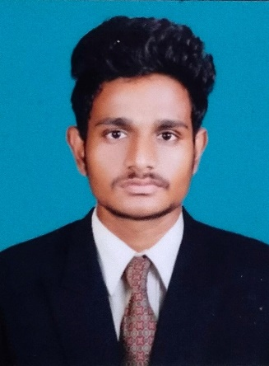

**Madhan kumar S**

Ph.no: +91 6382749878

Email: madhankumar67575@gmail.com

LinkedIn: https://www.linkedin.com/in/-madhankumar-s

Github : https://github.com/madhanop

**EXECUTIVE SUMMARY**

An aspiring Data Scientist professional with a certificate in post Graduate program in Data Analytics from Imarticus Learning. An Engineer pressuring Engineering in Electronics and Communication. Possess knowledge related to Machine Learning, Artificial Intelligence, Python, and Visualisation. Additionally skilled in Communication, Critical thinking, problem-solving, Empathy and Time Management. Looking forward to utilising these skills in the Data science and data Analytics industry.

**EDUCATION**

2021-2022 **Imarticus Learning.**

**Trichy,India**

● Certified post Graduate program in Data Analytics

▪ Machine Learning.

▪ Artificial Intelligence.

▪ Python.

▪ Deep Learning.

▪ Big Data

▪ Statistics And Probability

▪ Sql

2019 – 2023 **K Ramakrishnan of College Engineering**

**Trichy,India**

● Bachelors of Engineering (77.6%)

2017 - 2019 **Golden Gates Matric Hr Sec School**

**Perambalur,India**

● H.S.C (62.00%)

2017 **Golden Gates Matric Hr Sec School**

**Perambalur,India**

* S.S.L.C (67.02%)

**ACADEMIC PROJECT**

Project Title: “A study on **CELL PHONE DETECTOR**”.

Project Outcomes:

* Certain places where use of mobile phones are not allowed

like exam hall,temple,schools,college in those places to

detect the use of mobile phones this proposed system is

very helpful.

* This must detect the incoming and outing call,sms and video transmission

even if kept in the silent mode we can find the phone.

* Detection of hidden cell phones.

Paper Presentation Title: “Presented a paper on **SMART EYE TECHNOLOGY**”.

Project Title: “**GOOGLE PLAYSTORE**”.

Project Outcomes:

* We have predict by Machine learning.
* Models which will most likely have better performance are K Nearest-Neighbors, Logistic Regression, Decision Tree method and Random Forests. Once implementation of these models are learned, I will commit a change to this repo with the new results from all listed ML models.
* we can predict the rating when a app is given with the corresponding features, so that improve the user experience when surfing the Apps market and provide a early evaluation for developing the potential products.

**DATA ANALYTICS PROJECT**

● Automobile-data

● Credit Card analysis

● EDA

● Flight Manipulation Data

● Sentiment Analysis

● Gradient boosting

● Knn

● Cross Val score

● Black Friday

● bike analytical report

**ACHIEVEMENTS**

* Won a Prize in Picture arrangement competition in school days.
* Won a Best Student in school days.

**EXTRACURRICULAR ACTIVITIES**

* Photography.
* Acting in short film.
* Active sports person.

**SKILLS**

* Communication.
* Critical Thinking.
* Time Management.

**LANGUAGES KNOWN**

|  |  |  |  |
| --- | --- | --- | --- |
| Language | Read | Write | Speak |
| English | ✔ | ✔ | ✔ |
| Tamil | ✔ | ✔ | ✔ |